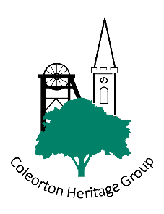
Coleorton House History Project

Sometime ago we acquired a small leather bound book with parchment pages. This was owned by Canon William Beresford Beaumont who recorded all the tenants who lived in the houses in Coleorton, crossing out each name as a new tenants moved in from 1875 to 1900.

Our idea is to try and do the same. Recording present day homes, their history and their occupants past and present.

To this end we ask, that you kindly find the time to fill in the form overleaf. If you have any photographs, old or present day and if you are happy for us to copy them please, place them in an envelope with your name, address, telephone or e-mail and return them to Terry or Shaelyn Ward at 153 The Moor, Coleorton. e-mail shaelyn100@aol.com or terryjward@aol.com. We promise to return them to you

Below are examples of pages from Canon Beaumont’s book, note the heavy crossings out! A transcript of the pages including crossed out names has been produced by Shaelyn and Terry.
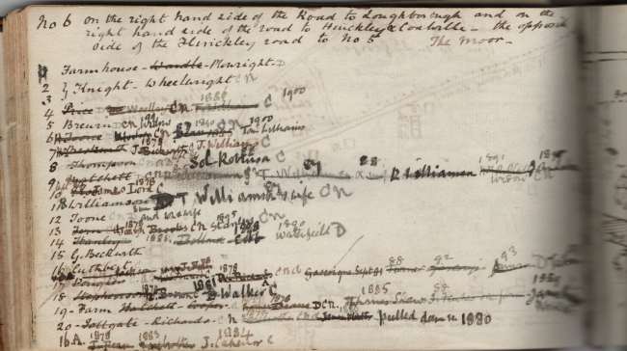

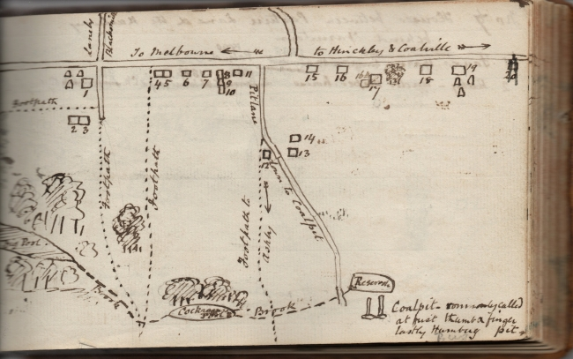
Coleorton House History Project

Date:

Name(s):

Address, how long have you lived here?

Contact details: (phone and / or email)

Names of previous occupants (if known).

Date built, has it been extended and when, any other history of the house you care to add. Have you found any items of interest in the house e.g. bread ovens, ingle nooks or in the garden e.g. wells, outhouses, privies, pigsties, bricks, clay pipes, pottery fragments etc?

